CONFIGURING AZURE AD PIM (PRIVILEGED IDENTITY MANAGEMENT)

STEP-01

THE BELOW IMAGE WE ARE BEGINNING TO CONFIGURE BASIC PIM SETTINGS. TO GET TO THE CURRENT SCREEN YOU WOULD GO TO AZURE PIM 🡪 MANAGE AND SELECT AD ROLES 🡪 THEN UNDER MANAGE AGAIN LOCATE SETTINGS.

FROM THERE YOU FIND THE ROLE YOUR GOING TO BE USING AND SELECT IT OR YOU CAN EDIT IT AS I AM DOING BELOW. I AM USING THE BILLING ADMINSTRATOR ROLE AND IM EDITING THE ROLE TO MEET THE NEEDS FOR THIS LAB.

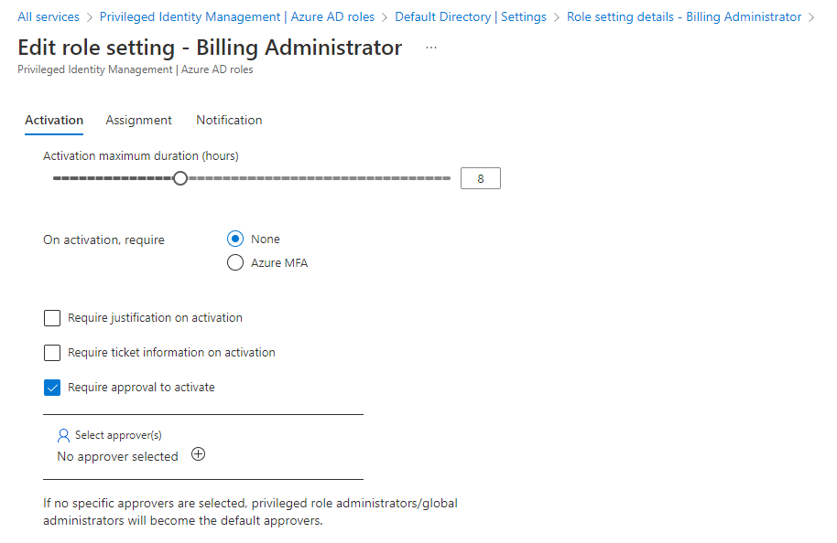

HERE WE CAN BEGIN MODIFYING THE ROLE TO MEET THE REQUIREMENTS AND STANDARDS OF THE ORGANIZATION. EXAMPLES WOULD BE ASSIGNING LEAST PRIVILEGE, ENSURING TWO FACTOR AUTHENTICATIONS IS BEING USED, SPECIFING WHEN THE PERMISSION/ASSIGNMENT IS ACTIVE/DEACTIVATED. AND PROVIDE NOTIFCATIONS USED BY THIS ROLE.

WHEN FINISH EDITING ROLE SELECT UPDATE AND YOUR CHANGES SHOULD AUTOMATICALLY GO INTO EFFECT.

STEP-02

IN THE IMAGE BELOW I ASSIGNED THE USER MIKE WALTON THE ROLE OF BILLING ADMINISTRATOR. TO ACHIEVE THIS, I WENT TO AZURE AD 🡪 USERS 🡪 SELECTED THE USER I WANTED TO GIVE THE ROLE TO 🡪 ASSIGNED ROLES 🡪 + (ADD) ASSIGNMENTS 🡪 SELECTED THE ROLE, IN THIS EXAMPLE THE BILLING ADMINISTRATOR ROLE 🡪 SELECTED THE MEMBERS OR USER TO ASSIGN ROLE TO, IN THIS LAB IT WAS MIKE WALTON.

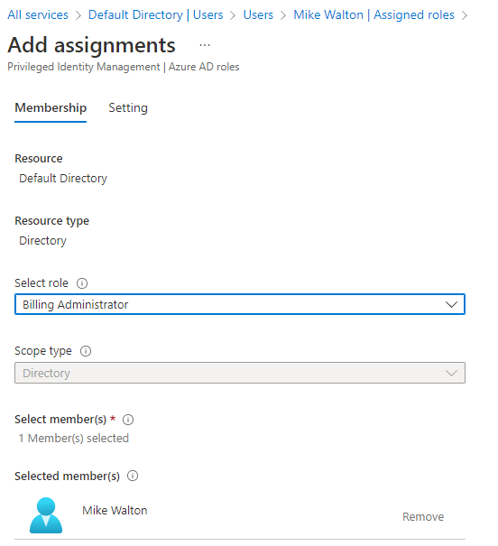

FOR THE IMAGE BELOW IS THE NEXT STEP WHERE YOU CAN DEFINE THE ASSIGNMENT TYPE IF YOU NEED IT NOW AND ACTIVATE THE ROLE OR IF IT’S A TEMPORARY ONE WHERE YOU SELECT A GIVEN DATE RANGE

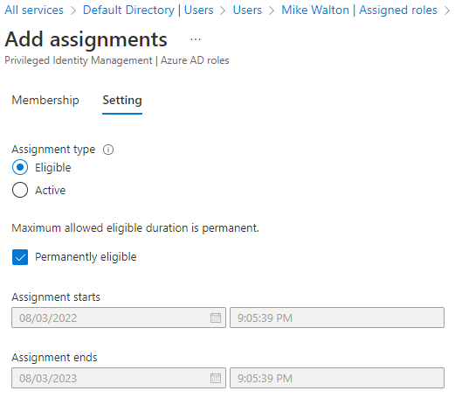

BELOW YOU CAN VERIFY THE USER WAS CONFIGURED PROPERLY. I ALSO RECEIVED AN EMAIL INFORMING OF THE USER REQUEST AND JUSTIFICATION FOR THE REQUEST WHICH ALLOWED ME TO DETERMINE THE DECISION TO APRROVE OR DENY THE ROLE FOR USER MIKE WALTON.

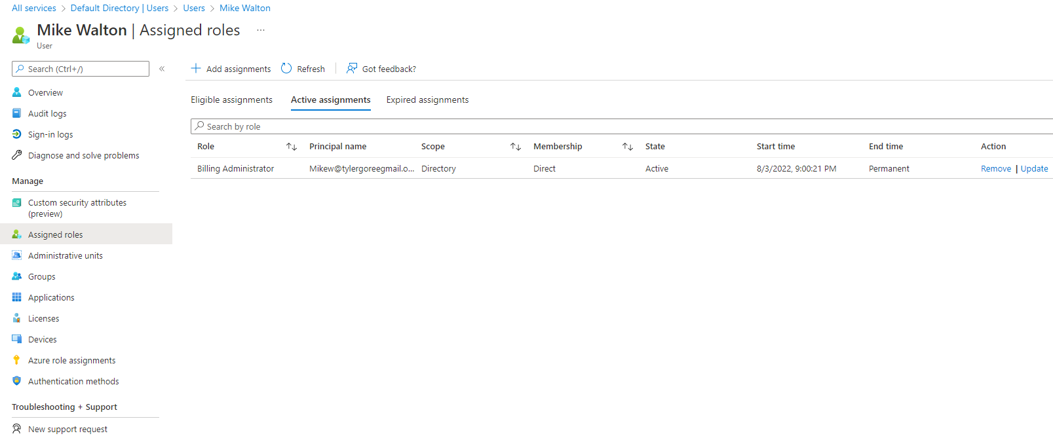

STEP -03

VERIFYING USER MIKE WALTON CAN SIGN IN

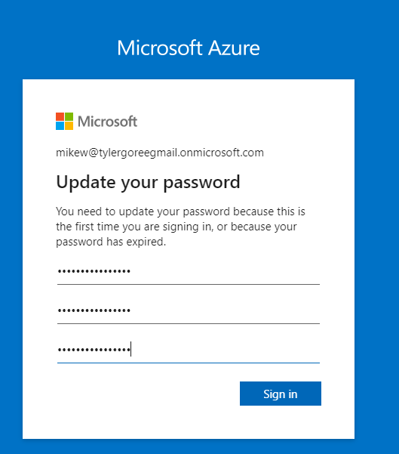

THE ABOVE IMAGE IS SHOWING THAT I DO HAVE ACCESS, BUT I AM HAVING TO CHANGE MY PASSWORD SINCE THIS WAS MY INITIAL LOGIN. THIS IS GREAT SECURITY PRACTICE AND IS STANDARD IS JUST ABOUT EVERY ORGANIZATION

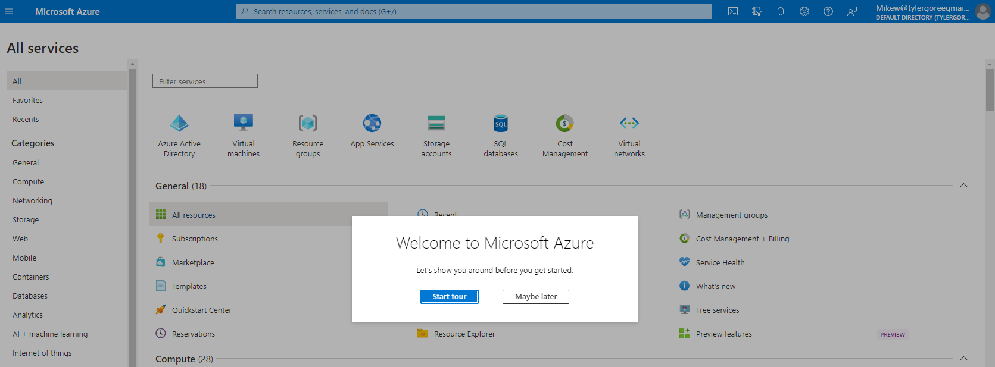

LOGIN WAS SUCCESSFUL!

STEP-04

ONCE SIGNED IN, ITS TIME TO VERIFY ROLE ASSIGNMENTS. TO GET THERE YOU GO TO AZURE AD PRIVILEGE IDENTITY MANAGEMENT 🡪 AZURE AD ROLES UNDER MANAGE 🡪 ASSIGNMENTS.

NOTE: I HAVE ALREADY ACTIVATED THE ROLE FOR MIKE IN STEP 02, BUT IF YOU DID NOT AND YOU SET IT TO AS an ELIGIABLE ASSIGNMENT HERE IS WHEN YOU ACTIVATE IT

